Directions
for Easybib.com

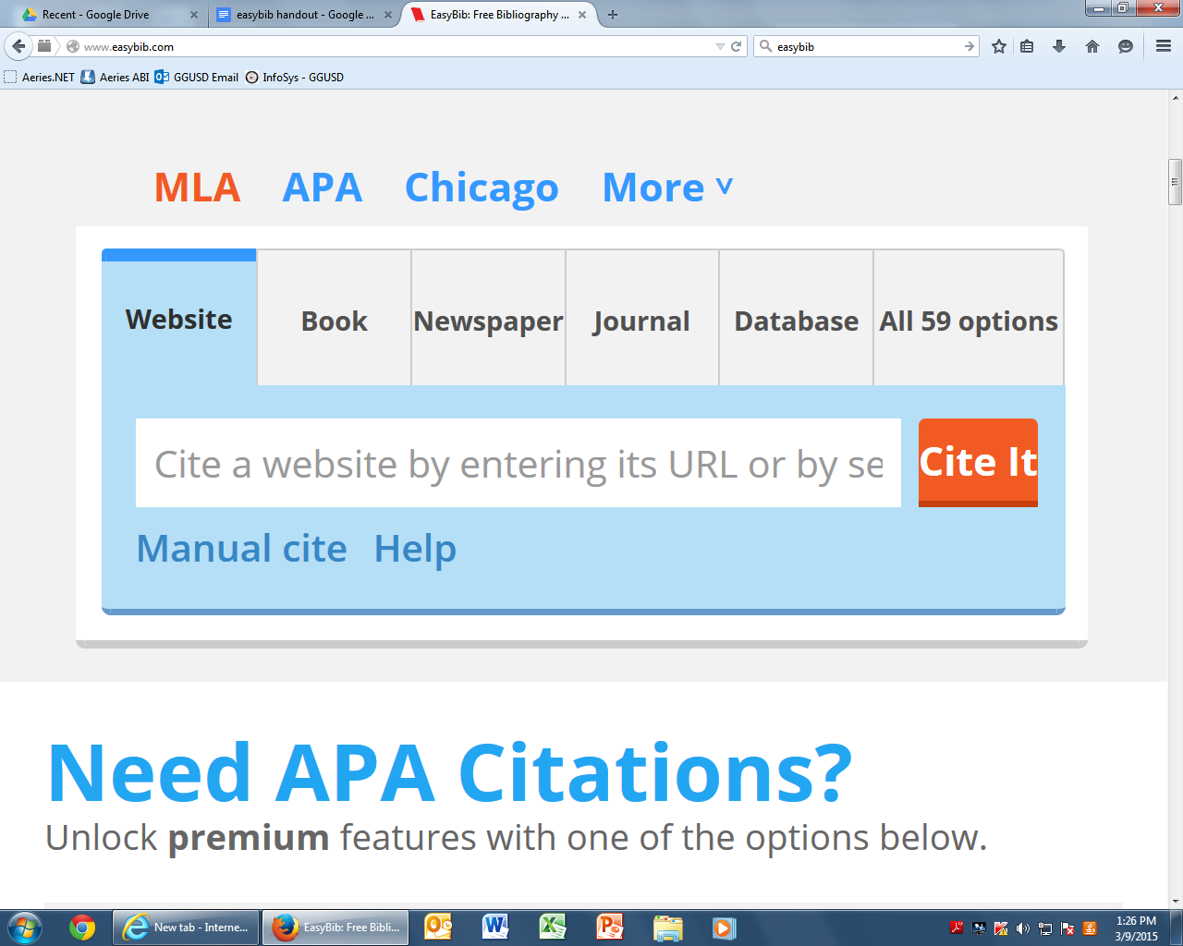

- Copy website URL into text box
- Click Cite It
- The website will display information found and needed
- Click Continue
- Look at website that is being cited for more information
  - ex. author, date, title
- Fill in additional information
- leave form blank when no information is available
- Click Create Citation
- Copy citation onto black document or works cited

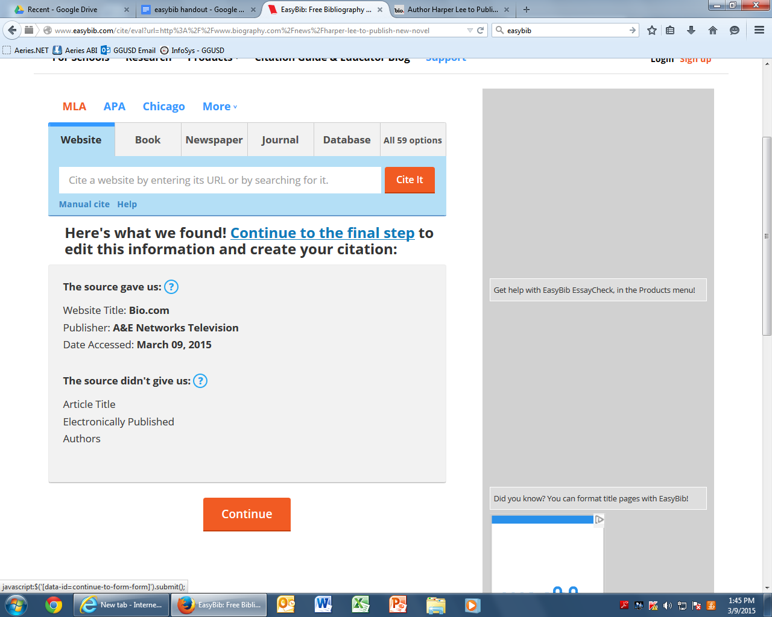

Additional Picture on Back
